1) Setup a highly available ecs cluster with load balancer and dynamic port mapping.  
NOTE:

Your cluster should maintain at least 6 tasks at any point of time and should be highly available across multiple AZ's.

Use the below image from deployment:

sabair0509/hiring-app:works

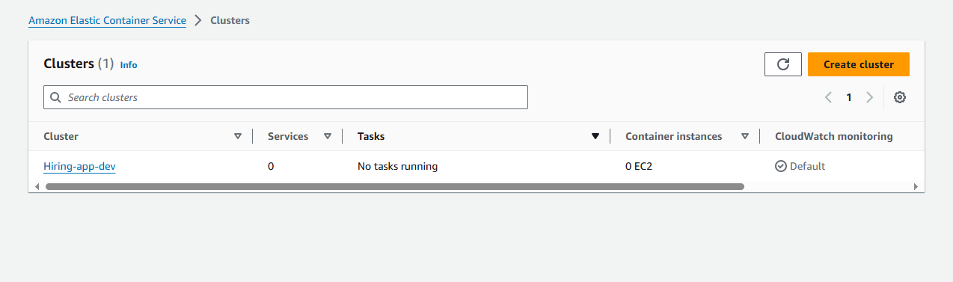  
The cluster has created two EC2 instances as we mentioned in configurations:  
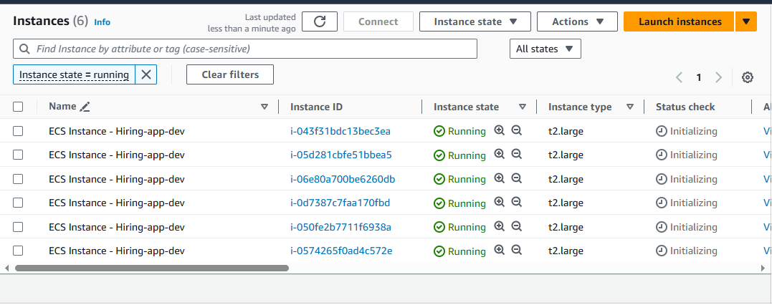

Also it has created the ASG for our cluster’s instance:  
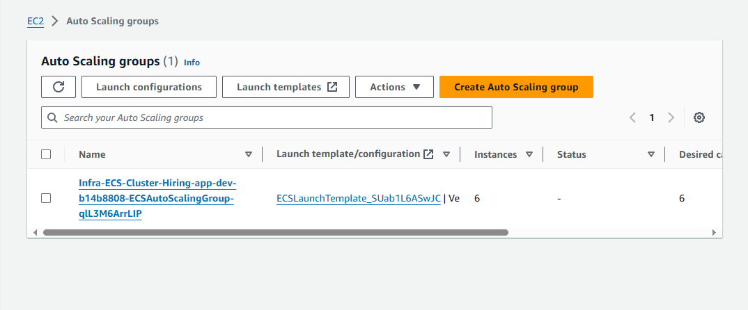  
  
connected one EC2 instances:  
  
Lets check the **docker version and agents** in EC2 instance: (In ECS by default Cluster will create the agents are used for communication purpose to make sure our docker container is running)  
  
  
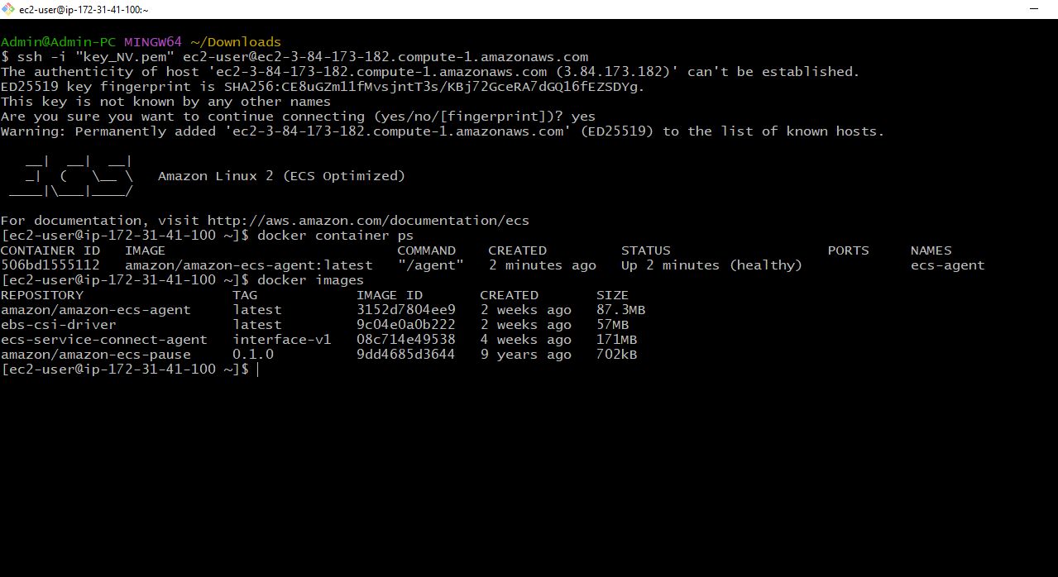  
  
  
  
  
  
  
  
  
  
  
  
  
Amazon Elastic Container Service 🡪Clusters 🡪hiring-app-dev 🡪Infrastructure

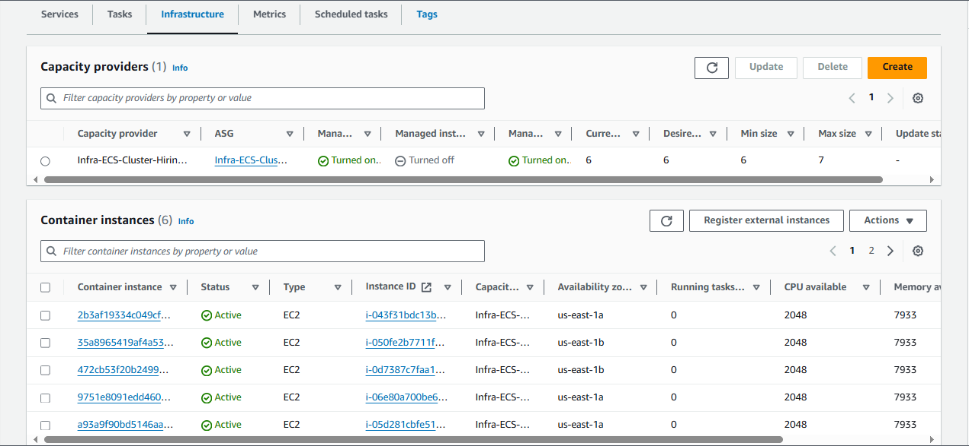  
  
lets create a task for our application, task is nothing but the blue print of our container for that we need to create **task definition**:  
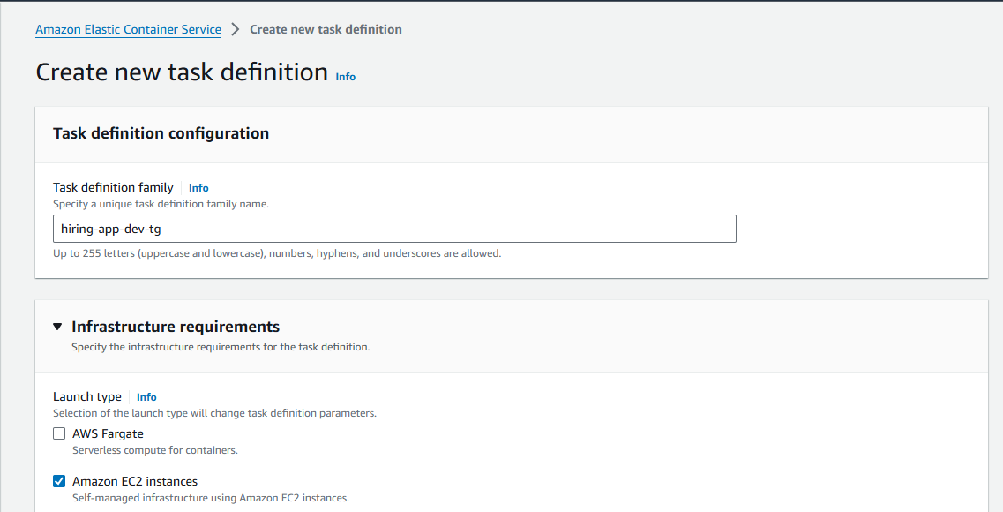  
  
Container details : as our container is running on 8080 port   
  
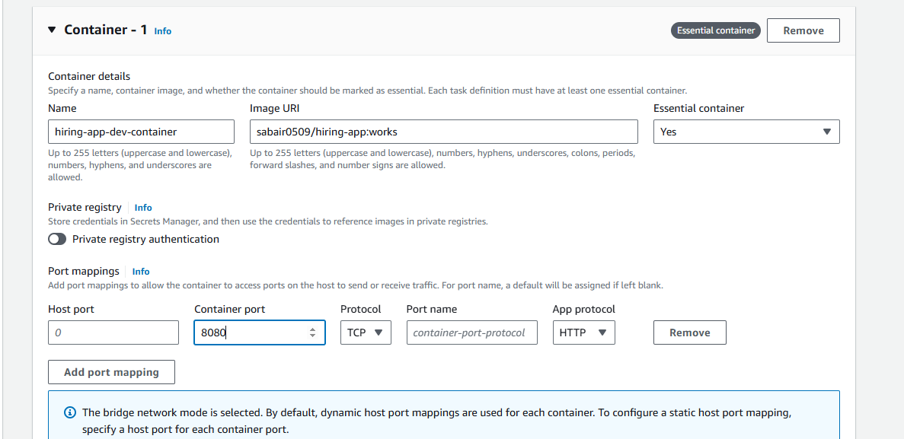

Lets run a task as our requirement is to run 6 tasks so I have mentioned task 6:  
  
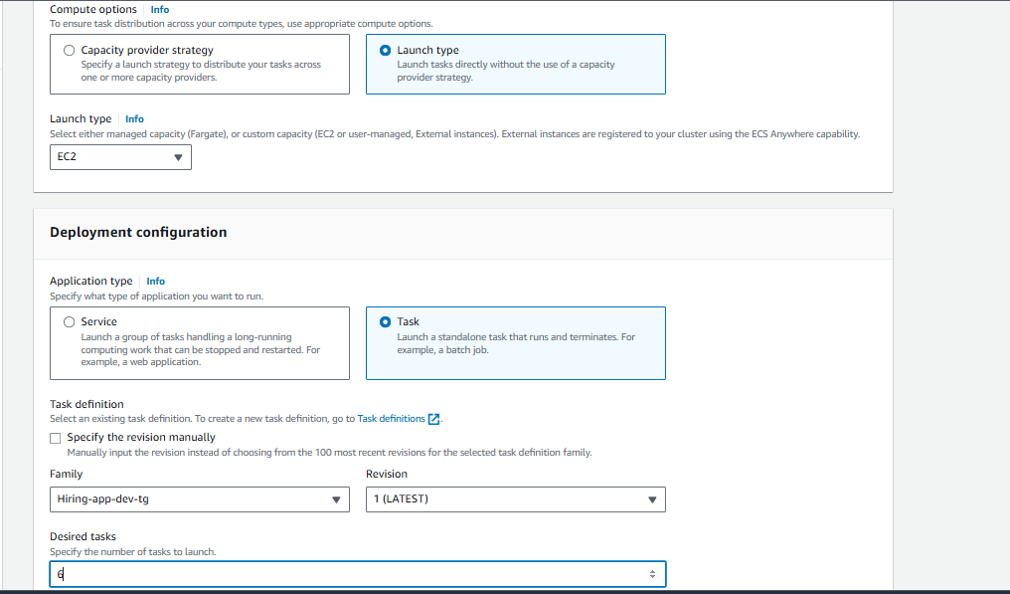  
We have to mention Task placement as **AZ balanced spread** it will balance the task in respective instance:  
  
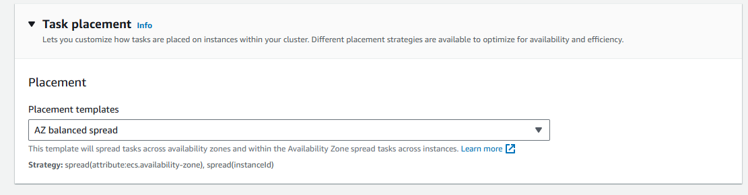

Create the task now:  
  
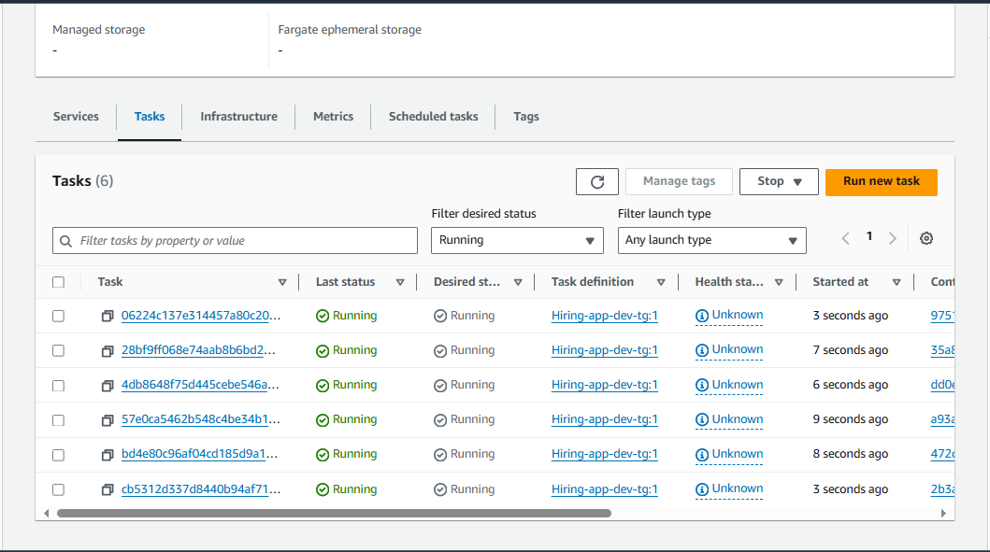  
Cross checked on WebUI:  
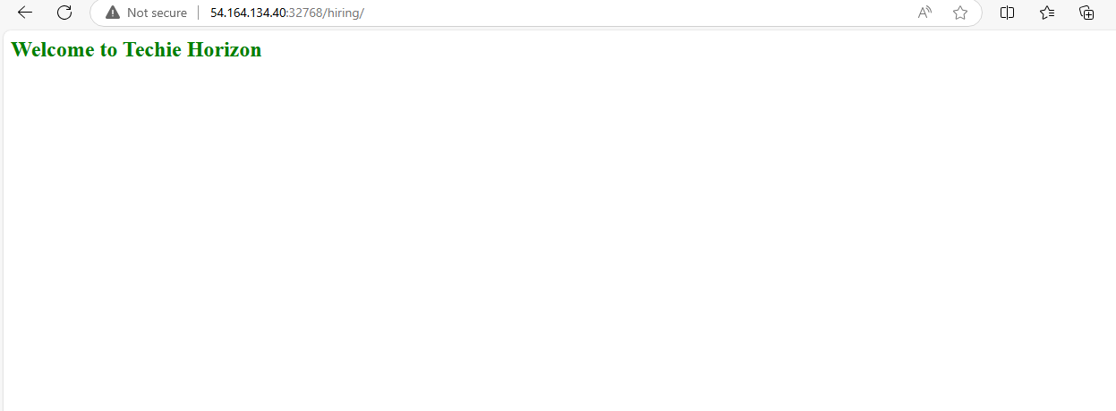  
Now, I have stopped all the tasks and creating a new service so that if any task has been stop by accident we don’t need to start it manually it should automatically also as I have used dynamic port mapping it is giving me random port I can’t give to anyone like this for that we need to give only one DNS name or one port to communicate for that we require an **Application Load Balancer** within **service** we are creating it:  
  
Let’s create a service now:  
First delete the   
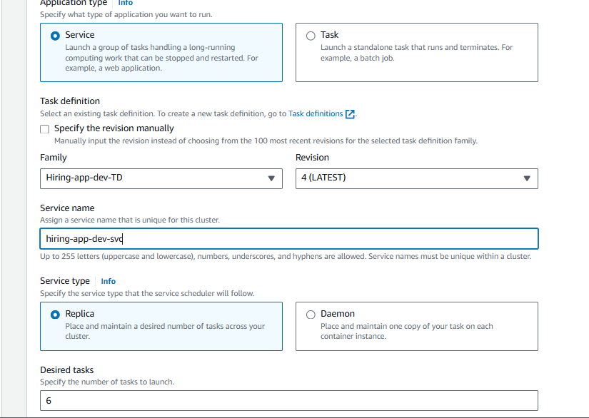  
In service only Created a Application load balancer with target group to use only one URL:  
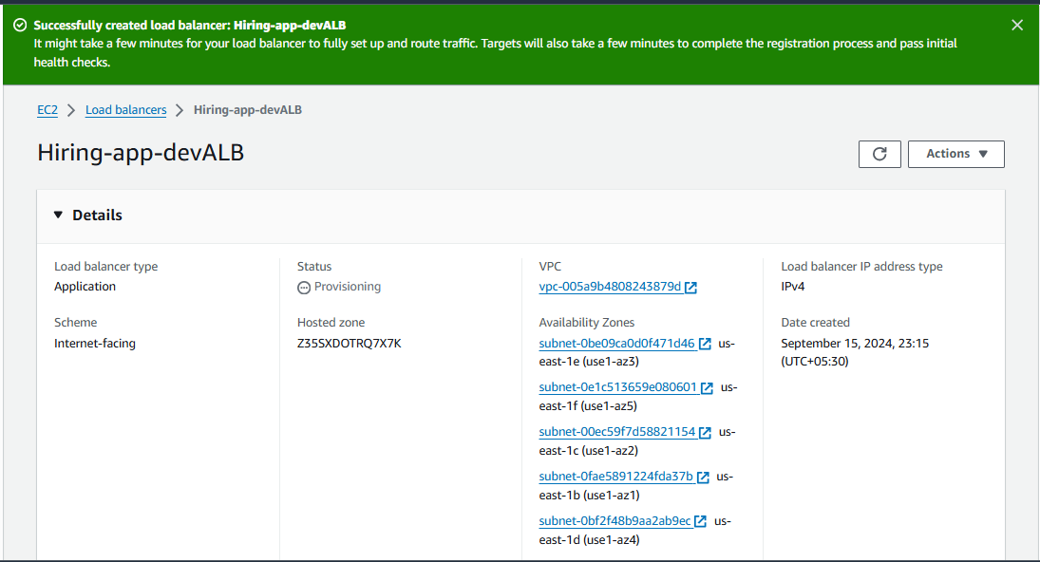  
attached the ALB to our service:  
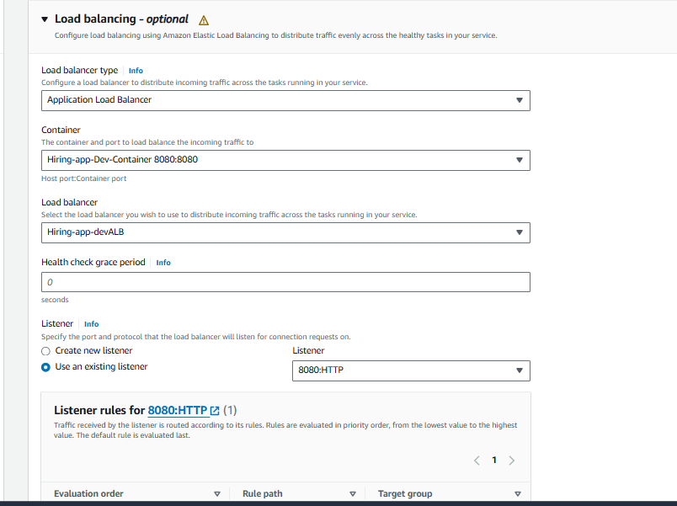  
after this configured the service auto scaling :  
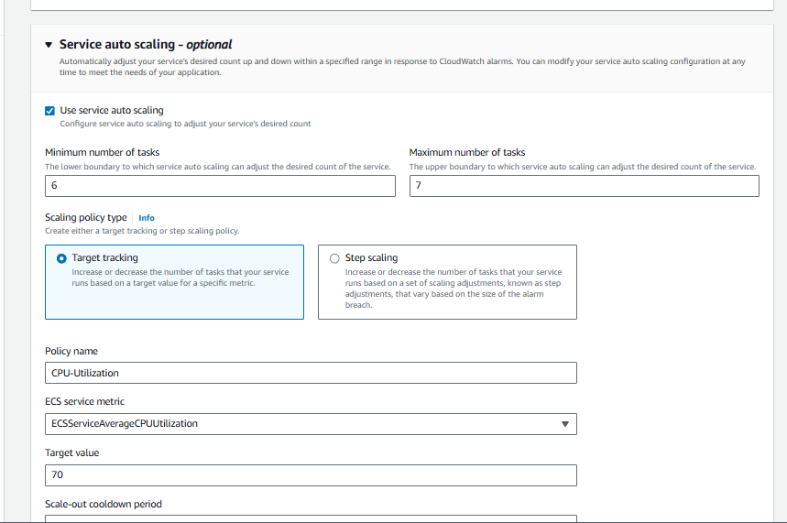  
  
Created:  
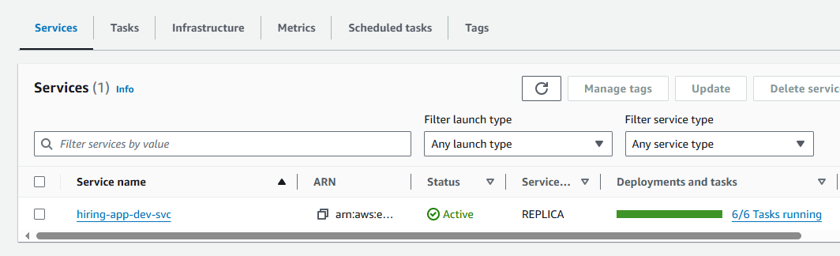   
  
Now lets go to our Load balancer and copy DNS name from it:  
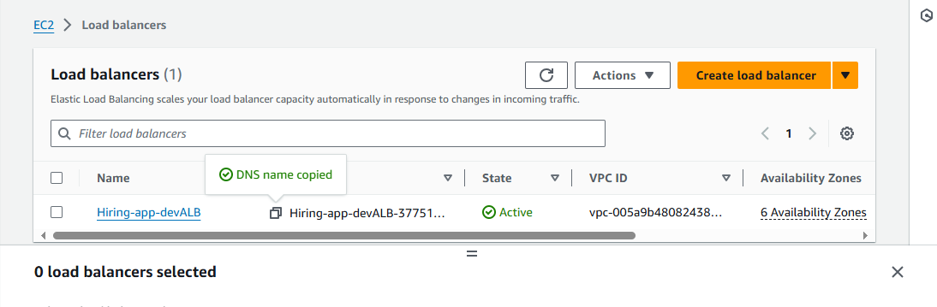  
  
  
  
**It’s working perfectly fine, Finally!!!!**   
